**Professional Service Agreement**

For

[Insert Client’s Name]

[Date]

[Company Logo]

**Contact Person:** (Name)

(Designation)

(Email)

(Tel / Mobile No)

**Ref:** MWS/(WS) or (TK)/(Reseller’s Initial)/(Client)/(month)/09

**MWS Premium Reseller:** (Name)

(Email)

(Tel / Mobile No)

**Company:**

**Address:**

**Tel:**

**Fax:**

**Website:**

**E-mail:**

**Table of Contents**

|  |  |  |
| --- | --- | --- |
| No | Title | Page |
| 1 | Executive Summary | 3 |
| 2 | MWS Features | 4 |
| 3 | MWS Learning Tracks | 5 |
| 4 | MWS Training Philosophy | 6 |
| 5 | MWS Trainers Kit | 7 |
| 6 | MWS Official Price List | 8 |
| 7 | MWS Investment | 9 |
| 8 | MWS Terms & Condition | 10 |

## Executive Summary

MiniWorkshopSeries is the product of years of research and development. We took the feedbacks and challenges faced by most large organizations, and came up with a training methodology to help progressive organizations achieve training effectiveness.

You can now leverage MWS unique resources to help drive business innovation and form a trusted foundation for strategic decision making increased agility, and long-term competitive advantage. Stay ahead of the competition with the innovative products and solutions available through MiniWorkshopSeries.

[add in the context of what the client has discussed / concern of / and how MWS and you can help them solve the challenges.]

***Advancing your organization begins here!***

MiniWorkshopSeries (MWS) offers a new approach and fresh perspective to competency-based trainings. It is designed to meet your every training need to achieve business results. Here is an exciting opportunity to challenge and inspire your organization to new heights.

## 

## MWS Features

MWS is a powerful, compact and dynamic **4-hour** workshop that delivers results for busy professionals and executives of progressive organizations.

* **Relevant and Applicable**MWS offers over 70 titles; making training useful, relevant and applicable to respective individual as well as the collective needs of your workforce.
* **Competency based**  
  MWS places emphasis on what the staff can do in the workplace as a result of completing the training. It provides for team learning from workshop to workplace.
* **Equal Opportunity for Learning**  
  MWS is specifically designed to be as effective for large number of participants as it is for smaller focus groups. It provides an equal opportunity for everyone to learn.
* **Cost Effective and Affordable**  
  MWS is flexible, cost effective and affordable solution for companies of all sizes.
* **Proven Technology**MWS is crafted with the NLP technology to not only deliver high quality content and information but mindset change. NLP bridges the knowing and doing gap.
* **Accelerated Learning Methodology**  
  MWS skill based and competency driven workshops are experiential, interactive and motivational. Its bite-size training workshop is clear, concise and precise to create high impact learning.

## 

## MWS Learning Tracks

**Powerful and Compact Workshops**

These workshops are specifically crafted to be as effective for large numbers of participants as they are for smaller focus groups. The workshops are independent of each other and are divided into the following learning tracks.

Visit [www.miniworkshopseries.com](http://www.miniworkshopseries.com) for more information.

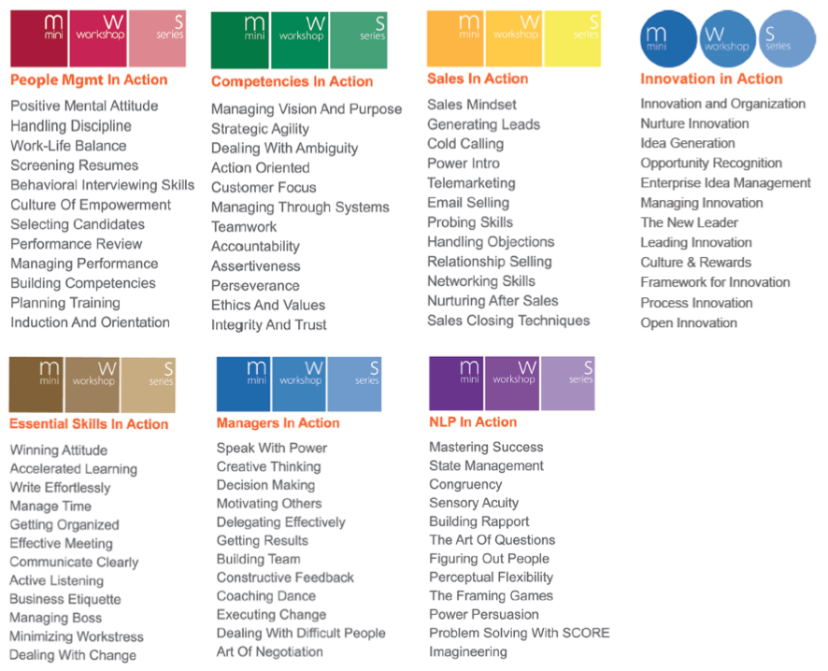

|  |
| --- |
| *To Empower People to Learn, Reflect, Discover and Change*  *By Creating A Fun Learning Environment*  *For Personal, Interpersonal & Organizational Transformation* |

## 

## MWS Training Philosophy

We aspire to empower and inspire people to have joyful fulfilling learning experience individually and collectively, to apply and transmit their learning profitably and be a contributor in the area of human excellence.

**Accelerated**: To master “Accelerated Change” requires Accelerated Learning; the ability to absorb and understand new information quickly, to retain that information and then to apply where appropriate. You and your participants will experience the training workshops in a highly interactive, relaxed, non-threatening and fun manner.

**Highly Interactive:** Our experiential learning workshops incorporate indoor and / or outdoor team initiatives, problem solving tasks and trust exercises. Concepts and background information are presented through group exercises, brainstorming sessions, discussion and activities creating an environment that facilitates accelerated learning and application.

**Fun & Inspiring:** We provide incredibly lively and entertaining events. Not only will you learn from the workshops, but be inspired to take actions. Availing yourself of information is one thing; but to be inspired is something entirely different. It is to feel the joy of living at your very best, to tap into your inner pride, strength, commitment and courage. These are the emotions that will drive you to apply what you have learned, for real and lasting results.

**Relevance & Application:** Most distinctive, these activities will be followed by a focused debrief by a skilled facilitator to link the learning to real life situations that the participants encounter. Our planning and design process guarantee the success of your training program whereupon the participants will find value and applications that would transfer back to the work environment instantly.

**Quality:** The quality of our work is guaranteed. We accelerate continuous improvement to exceed the expectations of our clients. Our commitment to your outcome is our utmost priority.



Get to know us better visit [www.miniworkshopseries.com](http://www.miniworkshopseries.com) now

## MWS Trainers Kit

***Beyond Training***

***Beyond Excellence***

***Beyond Competencies***

Today with the **MWS Trainers Kit licensing option**, you will be able to have regular comprehensive company-wide training interventions for a fraction of the cost. Many organizations has benefited from developing their line managers, in-house trainers and HR Practitioners to deliver training workshops effectively.

**Here are the 7 reasons why: -**

|  |  |
| --- | --- |
| 1 | **Save Time & Cost:** With MWS Trainers Kit, you will save over 80% of your training investments and benefit from a professionally well researched content that delivers comprehensive yet compact key skills, tips, and knowledge to build on your human capital. |
| 2 | **High Involvement Approach:** MWS is specifically crafted for progressive organizations that believe in a high involvement of their management team in their staff development. This empowers the leaders in the organization to take an actionable and structured approach in the development of their team. Walking the talk becomes the culture because the managers are the ones that inculcate these competencies. |
| 3 | **Learning Agility:** MWS encourages leaders to be adaptable and agile in applying this learning experience. They will bring their market experience, relevant case studies and wisdom, adding context to the content. As a result, the managers also instinctively raise their standards at their workplace thus instilling leadership and mutual respect. |
| 4 | **Common Competency Language:** Having everyone attend the same trainings, it improves on the effectiveness and clear expectations for everyone. Not only will they speak the same lingo; but relate to the same tool, tips and concept, experiences and reinforce what is learned from the workshop to the workplace. |
| 5 | **Enabling Learning Reinforcement:** Your staffs are no longer required to attend isolated one off programs giving everyone the opportunity to attend regular in-house trainings. This will enable them to continuously learn, change and adapt learning at work effectively. |
| 6 | **Boosts teamwork and inspires leadership:** MWS cultivates the culture of continuous learning and inspires leadership when your people meet regularly in a non-threatening learning environment. This encourages an enormous sense of loyalty and belonging as well as boost teamwork. |
| 7 | **All the work is done for you:** You will have access to instant product and resources: Presentation Slides, Trainers Notes and Learning Journals. What’s more...with the MWS Trainers Kit, you have **unlimited printing rights.** |

## MWS 2011 Official Price List

|  |  |  |  |  |
| --- | --- | --- | --- | --- |
| **No** | **Items** | **Notes** | **Unit/License** | **RM** |
| 1 | MWS Trainers Kit | Any Titles | 1 Title  12 Titles  36 Titles | RM4, 200  RM42, 000  RM75, 000 |
| 2 | MWS Licenses Trainer (Pro) | 3 days LTC  6 days NLP  1 day Coaching | 1 pax | RM8, 000 |
| 3 | MWS Licensed Trainer (Ess) | 3 Days LTC  1 day Coaching | 1 pax | RM4, 000 |
| 4 | MWS Workshops (In-House) | 30 pax | 1 workshop | RM3, 000 |
| 5 | MWS Workshop (Public) |  | 1 pax | RM300 |

The above is the MWS Official Pricing for 2011. To ensure fair pricing for all clients, MWS operates on a controlled pricing. However, with each quarter we do launch Special Promotions specially designed for clients to take advantage of.

## 

## MWS Investment

MWS Training Workshops

|  |  |  |  |  |
| --- | --- | --- | --- | --- |
| No. | Tracks | Titles | No of Pax | Total Amount (RM) |
| 1. |  |  |  |  |
|  | **Total Investment** | | |  |

MWS Trainers Kit

|  |  |  |  |  |
| --- | --- | --- | --- | --- |
| No. | Tracks | Titles | No. of Sets | Total Amount (RM) |
| 1. |  |  |  |  |
|  | **Total Investment** | | |  |

MWS Licensed Trainers

|  |  |  |  |  |
| --- | --- | --- | --- | --- |
| No. | Licensing Options | No. of Pax | Licensing Fees  per pax | Total Amount (RM) |
| 1. | MWS Licensed Trainer [Essential] |  | 3,000.00 |  |
| 2 | MWS Licensed Trainer [Professional] |  | 6,000.00 |  |
|  | **Total License Fees** | | |  |

## Client Total Investment

|  |  |
| --- | --- |
| Total Investment MWS Training Workshops |  |
| **Total Investment MWS Trainer Kit** |  |
| Total Investment MWS Licensed Trainer |  |
| **Client Total Investment (RM)** |  |

## MWS Terms and Conditions

|  |  |
| --- | --- |
| **Content Licensing Agreement, Licensed Trainer Agreement and Term of Use** | Please login at <http://www.miniworkshopseries.com> to view and adhere to all MiniWorkshopSeries Licensing Agreements as stipulated therein. MiniWorkshopSeries reserves the rights to take any legal actions against those who are found in breach of any MWS related Licensing Agreements. |
| **Intellectual Properties** | Learning Journals remain the intellectual property of MiniWorkshopSeries and may not be reproduced without express permission or used for courses not conducted or organized by MiniWorkshopSeries and its license holders. |
| **Number of Participants**  (Applicable only for MWS workshops) | The training workshops quoted are for 30 pax. Additional pax would entail RM50.00 per pax. The number of participants per workshop is crucial to the effectiveness of our workshop as our training methodology is highly interactive and experiential. Please adhere to the following recommendations:   * MiniWorkshopSeries: Min: 15 Optimized: 25 Max: 60 |
| **Learning Environment**  **& Venue Condition** | It is highly recommended that there is **sufficient ‘break-out’ space** for activities and games. [min: 20ft by 20ft]  Sitting Arrangement:   * Theater |
| **Audio Visual Requirements** | The following is required for the training workshops:   * Flip charts with paper (Qty: 2) * Marker Pens (multicolor – 4 sets) * Data Projector & Screen * Lapel Microphone [for above 30pax] |
| **Offer Validity** | This Professional Service Fee is only eligible upon agreement being agreed upon and signed within 30 days from the date of proposal or service quotation unless otherwise specified. |
| **Acceptance** | The signatures below indicate acceptance of the details, terms, and conditions in this proposal and provide approval to begin work as specified. Alternatively, your deposit indicates full acceptance, and will also signify approval to begin. Or you can also confirm your acceptance in writing via email. |
| **Trainer Bookings**  (Applicable only for MWS workshops) | Please take note that MWS Licensed Trainer availability dates are booked in on a first served, first in basis. We trust you can give us a confirmation as soon as possible because we want to serve you even better. In the event of the unavailability of the proposed trainer, an equally competent MWS Licensed Trainer will be recommended for your consideration. |

|  |  |
| --- | --- |
| **Food & Beverage**  (Applicable only for MWS workshops) | The client shall be responsible for the venue and the F&B requirements (if any) of the participants, MWS Licensed Trainer, and assistants. |
| **MWS Training outside Klang Valley**  (Applicable only for MWS workshops) | The client shall bear the following cost for the Trainer and his team.   * By Air: Return Ticket from KL International Airport. Plus airport transfers to and fro both in KL as well as destination * By Car: If traveling is by means of car transport, mileage claims of RM0.80 per km would be charged to the client. Mileage distance is calculated from Subang Jaya to destination. * Hotel Accommodation [minimum 3 star hotel] for the MWS Licensed Trainer and Learning Advocate [2 rooms] * Per diem charges of RM100 per day (plus non-training days) |
| **Cancellation policy** | The quality of our work is guaranteed. However you may postpone, or delay this project as your business needs may unexpectedly dictate; with a penalty of 10% of the total project investment if notification of the postponement of the workshop is notified within 7 days from the date of the commencement of the workshop. In the event of a total cancellation less than two weeks before the engagement date, the full amount is payable. |

Ref:

# ACCEPTANCE

The signatures below indicate acceptance of the details, terms, and conditions in this proposal and provide approval to begin work as specified. Alternatively, your deposit indicates full acceptance, and will also signify approval to begin.

For MWS Premium Reseller:

-Signature-

(Name)

(Email)

(Tel / Mobile No)

Company:

Address:

Tel:

Fax:

Website:

E-mail:

For **(Client’s Company Name)**

-Signature-

Name:

Designation:

Date: